Figures used
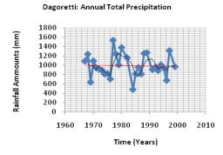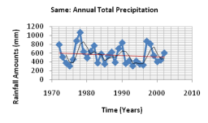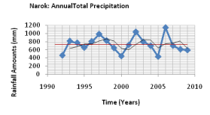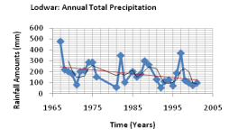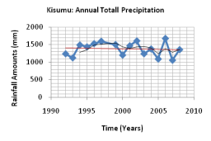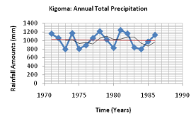
Figure 2a: Observed rainfall (blue), locally weighted regression (black) and trend of unsmoothed annual precipitation totals (continuous red line)
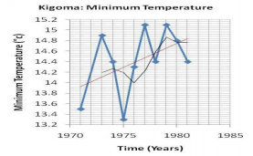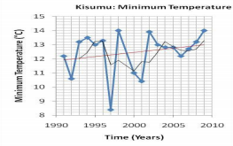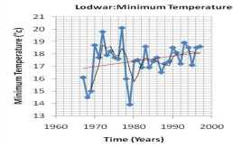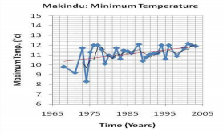
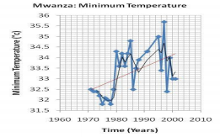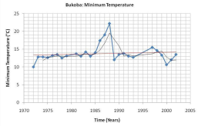
Figure 2b: Observed minimum temperature (blue), locally weighted regression (black) and unsmoothed annual minimum temperature trend (continuous red line)

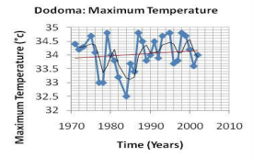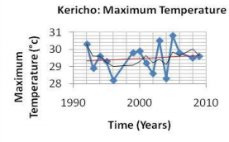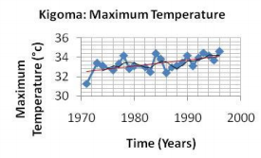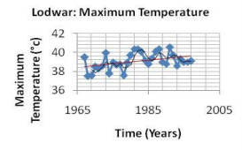
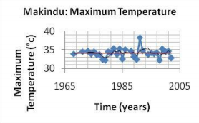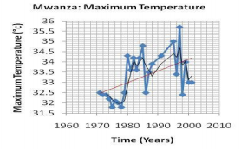
Figure 2c: Observed maximum temperature (blue), locally weighted regression (black) and unsmoothed annual maximum temperature trend (continuous red line

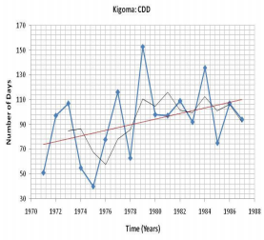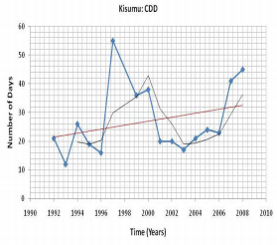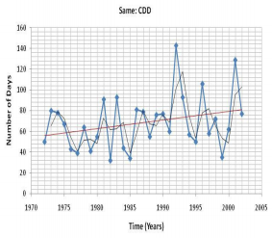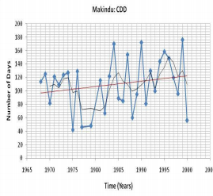
Figure 2d: Observed dry days (blue), locally weighted regression (black) and unsmoothed annual consecutive dry days trend (continuous red line)

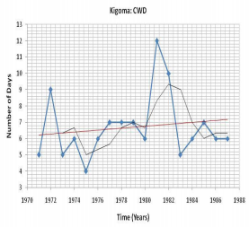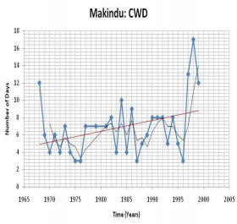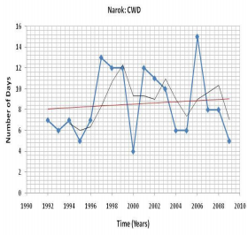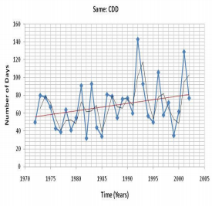
Figure 2e: Observed wet days (blue), locally weighted regression (black) and unsmoothed annual consecutive wet days trend (continuous red line) during the period 1960 to 2009 for various stations

Appendix B
No | Station | Lon | Lat | No | Station | Lon | Lat
1 | Dagoretti | 36.8 | -1.3 | 18 | Narok | 35.9 | -1.1
2 | Garissa | 39.6 | -0.5 | 19 | Voi | 38.6 | -3.4
3 | JKIA | 36.9 | -1.3 | 20 | Wilson | 36.82 | -1.32
4 | Kakamega | 34.8 | 0.3 | 21 | Wajir | 40.07 | 1.75
5 | Kisumu | 34.8 | -0.1 | 22 | Gulu | 32.3 | 2.8
6 | Lamu | 40.9 | -2.3 | 23 | Kasese | 30.1 | 0.2
7 | Lodwar | 35.6 | 3.1 | 24 | Entebbe | 32.5 | 0.1
8 | Makindu | 37.8 | -2.3 | 25 | Jinja | 33.2 | 0.5
9 | Marsabit | 38 | 2.3 | 26 | Kigali | -1.9 | 30.1
10 | Mombasa | 39.6 | -4.1 | 27 | Kamembe | -2.5 | 28.9
11 | Moyale | 39.1 | 3.5 | 28 | Gisenyi | -1.7 | 29.3
12 | Msabaha | 40.1 | -3.3 | 29 | Mbeya | 33.5 | -8.9
13 | Mtwapa | 39.7 | -3.9 | 30 | Mbozi | 32.75 | -8.75
14 | Bukoba | -1.3 | 31.8 | 31 | Kigoma | -4.9 | 29.6
15 | Dodoma | -6.2 | 35.8 | 32 | Mwanza | -2.5 | 32.9
16 | Eldoret | 0.5 | 35.3 | 33 | Same | -4.1 | 37.8
17 | Kericho | -3.7 | 35.4 | 34 | Songea | -10.7 | 35.6

